Digitest® 3: Best Practices and Common Mistakes to Avoid.

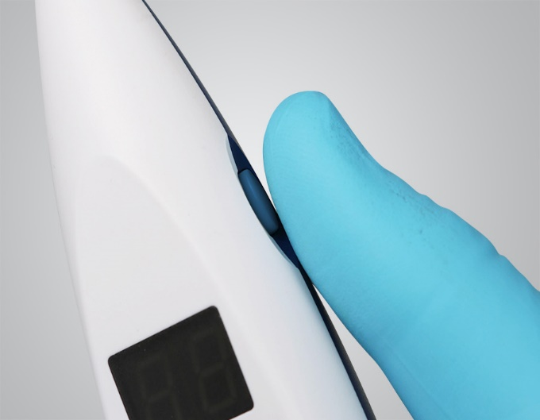
Digitest® 3 is built to simplify pulp vitality testing while ensuring reliable results. Even so, regular care is key to keeping it accurate and performing well. We’ve
Compiled some tips to help you maintain your device and achieve optimal results.

Best Practices

- Pair pulp testing with x-rays, hot/cold, or percussion for complete diagnostics.
- Keep probes and clips spotless according to our IFU.
- Use Digitest® 3 accessories with confidence, even on older Digitest models.
- Protect the power unit by cleaning with wipes under 30% alcohol, or alcohol-free disinfectants.

What to Avoid?

- Using Digitest® 3 with patients who have pacemakers, defibrillators, or insulin pumps.
- Using accessories from other third-party pulp.
- Soaking, spraying, or machine-washing the power unit.

Simple habits can have a big impact on your device’s accuracy and longevity. Discover how to achieve reliable, lasting results.

